Intercamp Kit List
Remember for this expedition we will be traveling through the airport and walking to our site upon arrival. It is important that they young people are aware that they will be required to carry their own bags during these periods. For this reason, I strongly recommend a hiking rucksack however this is not essential.
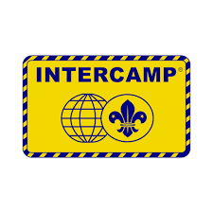
Main Luggage (Hold luggage for the aircraft)
- Essential
  - Medication for the weekend (to check in and show Nigel upon arrival at Heathrow)
  - Sleeping bag
  - Roll mat
  - Torch
  - Waterproof jacket
  - Warm hat/sun hat/Suncream
  - Warm jumper/fleece
  - T-shirts
  - Pairs of trousers/Shorts
  - Socks
  - Underwear
  - Walking boots
  - Trainers/Secondary pair of footwear (not crocs/flip flops)
  - Small Personal wash kit/Dry soap/Wet wipes (There is limited access to showers)
  - Towel
  - Tea Towel
  - Plate • Bowl • Plastic/Travel Mug for hot drinks • Knife, fork, and spoon
  - Empty Plastic Water bottle (don’t travel with this full)
- Optional
  - Waterproof trousers
  - Gaiters (optional)
  - Scarf/head-over and gloves
  - Blanket and pillow (both very optional!)
  - Teddy Bear/Cuddly Toy
Hand Luggage (Carry on)
- Essential
  - Medication required whilst traveling with doctors letter if required.
  - A small bottle of water to discard prior to heading through security.
  - Entertainment (i.e books, cards, pen & paper etc)
  - Money/Wallet if they want to buy food/drinks through the airport.
- Optional
  - Hard boiled sweets for the flight (help with ears popping)
  - NO CHOCOLATE or Crisps (Chocolate melts and crisps explode)
  - Pillow/eye mask
  - Ear Plugs
  - Lip balm
  - Hair Ties

